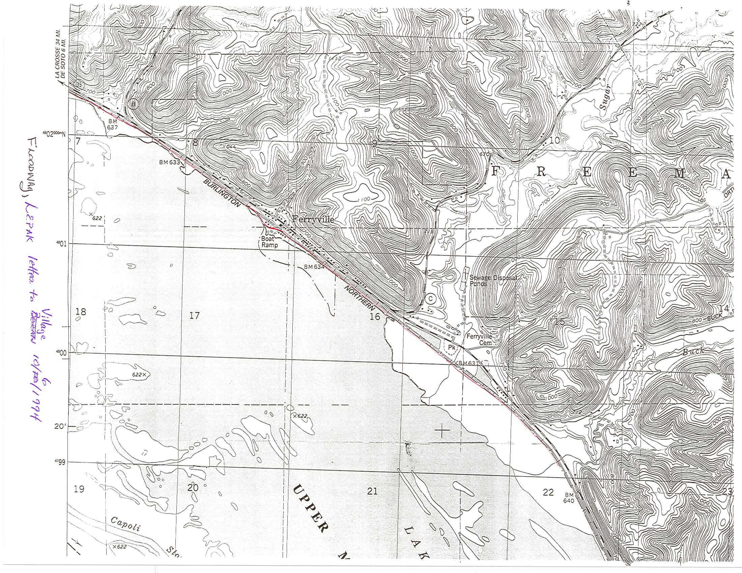

Ferryville Boat Ramp Area Floodway District
Created 12-17-2010

